<https://stackify.com/streams-guide-java-8/>

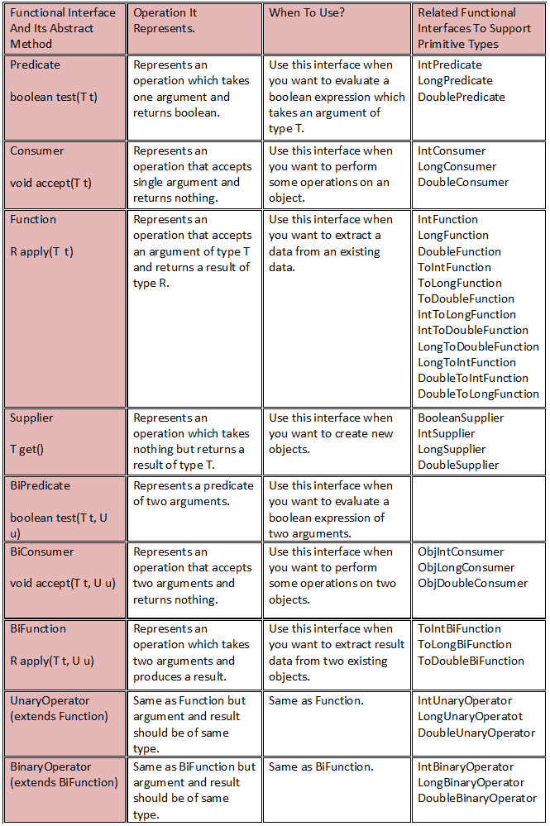

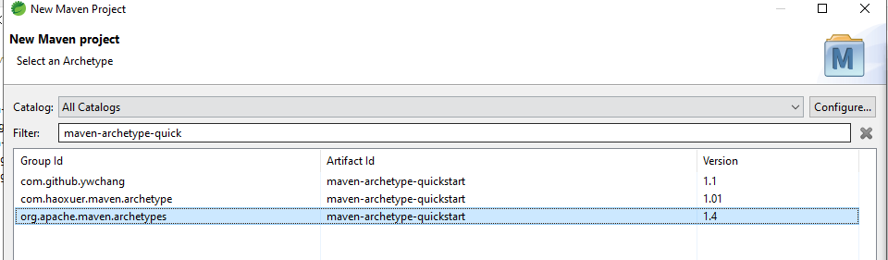

FI:

Lambda expressions internally used FI only.

<https://www.tutorialspoint.com/java8/java8_functional_interfaces.htm>

<https://www.javaguides.net/p/java-8.html>

<https://mkyong.com/tutorials/java-8-tutorials/>

<https://howtodoinjava.com/java-8-tutorial/>